Regressions with Interaction Effects

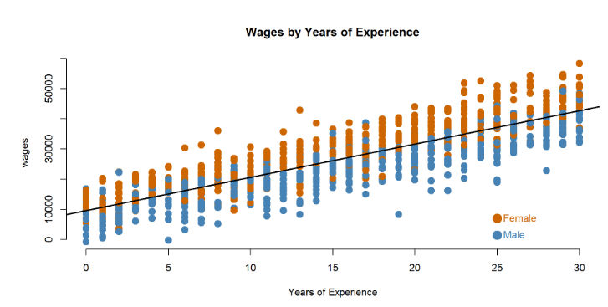

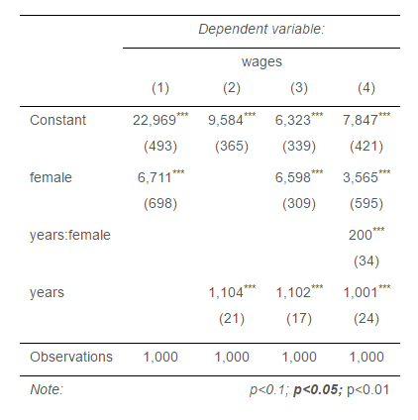

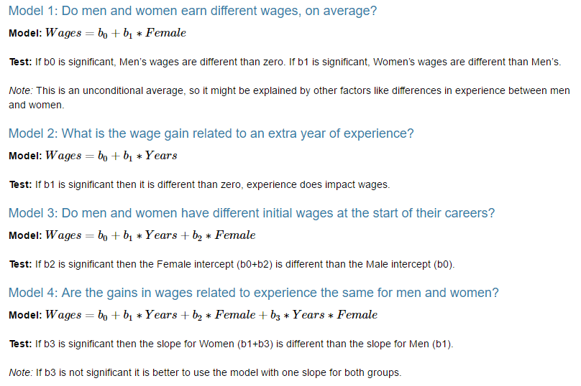

**Use Model 4 to answer the following questions:**

1. How much do men earn in their first job (zero years of experience)?
2. How much do women earn in their first job?
3. What is the average raise men receive each year?
4. Do men and women receive different raises? How do we know?
5. What is the average raise women receive each year?